Muhammad Umar Writing Task 1
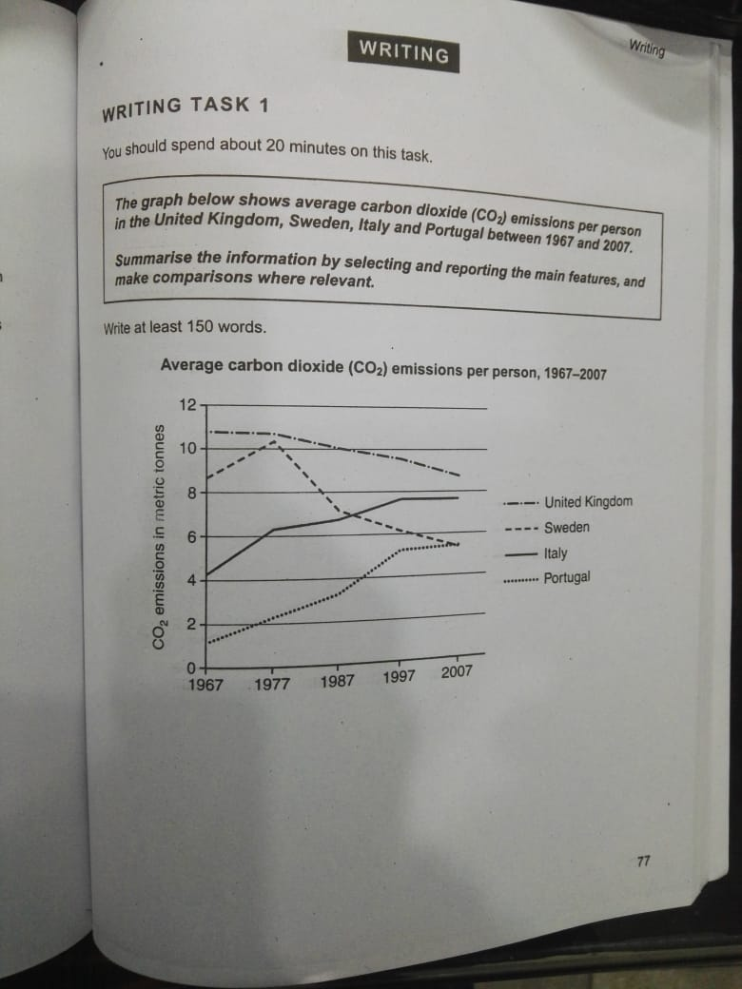
The provided graph illustrates the average carbon dioxide (CO₂) emanation per capita in the United Kingdom, Sweden, Italy, and Portugal from 1967 to 2007.
Overall, the carbon discharge per person in the United Kingdom and Sweden experienced a downward trend, while Italy and Portugal showed a steady and significant rise over the period.
Looking at the details, the United Kingdom had about 10.4 metric tonnes of carbon emissions in 1967 and remained relatively stable until 1977. From 1977 onwards, there was a steady decline, reaching approximately 8.3 metric tonnes by 2007. Meanwhile, Sweden also showed an overall decline, though with some fluctuations. It started at 8.3 metric tonnes in 1967, decreased rapidly until 1987, and then continued to drop slightly, approaching nearly 4.8 metric tonnes by the end of the period.
On the other hand, Italy showed an upward trend throughout the period. It started at 4.1 metric tonnes in 1967 and rose steadily to around 6.3 metric tonnes by 1977. Between 1977 and 1997, emissions continued to increase gradually, reaching about 7.8 metric tonnes, and then stabilized until 2007. Similarly, Portugal experienced a sharp increase from 1967 to 1997, with emissions rising from 0.8 to 4.7 metric tonnes, followed by a gradual and slight increase over the remaining years.

